8: Online Hospital Appointment Booking System
Aim: To design and develop an online hospital appointment booking system that enables patients to search for hospitals and doctors, book appointments, check appointment status, and manage their medical appointment history.
Algorithm:
- Start the application.
- Register and log in as a patient or hospital administrator.
- Search for hospitals by location and doctors by specialty.
- Display hospital details, doctor information, and available appointment slots.
- Select a hospital, doctor, preferred date, and time.
- Enter patient details and submit the appointment request.
- Confirm the appointment and display its status.
- Allow patients to view appointment history, submit check-in forms, and provide reviews.
- Allow hospital administrators to manage hospital details, doctors, schedules, appointments, and statistics.
- Stop.

Code : ```html
<!DOCTYPE html>
<html lang="en">
<head>
<meta charset="UTF-8">
<meta name="viewport" content="width=device-width, initial-scale=1.0">
<title>MedCare Appointment System</title>

<style>
*{box-sizing:border-box}
body{margin:0;font-family:Arial,sans-serif;background:#f2f7fb;color:#243447}
header{background:#075985;color:white;padding:16px 5%;display:flex;justify-content:space-between;align-items:center;gap:12px;flex-wrap:wrap}
header h2{margin:0}
nav{display:flex;gap:7px;flex-wrap:wrap}
button{border:0;border-radius:7px;padding:10px 13px;background:#0284c7;color:white;cursor:pointer;font-weight:bold}
button:hover{opacity:.88}
.secondary{background:#e2e8f0;color:#1e293b}
.danger{background:#dc2626}
.success{background:#15803d}
main{max-width:1100px;margin:24px auto;padding:0 15px}
.hero{background:linear-gradient(120deg,#075985,#0ea5e9);color:white;padding:28px;border-radius:15px;margin-bottom:20px}
.hero h1{margin-top:0}
.panel{background:white;padding:20px;border-radius:12px;margin-bottom:18px;box-shadow:0 3px 15px #0000000b}
.grid{display:grid;grid-template-columns:repeat(auto-fit,minmax(190px,1fr));gap:14px}
.field{display:flex;flex-direction:column;gap:6px}
label{font-size:14px;font-weight:bold}
input,select,textarea{padding:11px;border:1px solid #cbd5e1;border-radius:7px;font:inherit;width:100%}
textarea{min-height:90px}
.actions{display:flex;gap:8px;flex-wrap:wrap;margin-top:14px}
.hidden{display:none!important}
.card{border:1px solid #dbe5ee;border-radius:10px;padding:16px;margin:12px 0}
.card h3{margin-top:0}
.muted{color:#64748b;font-size:13px}
.badge{display:inline-block;padding:5px 9px;background:#dcfce7;color:#166534;border-radius:20px;font-size:12px;font-weight:bold}
.cancelled{background:#fee2e2;color:#991b1b}
.pending{background:#fef3c7;color:#92400e}
.stats{display:grid;grid-template-columns:repeat(auto-fit,minmax(150px,1fr));gap:12px}
.stat{padding:17px;background:#eaf6ff;border-radius:10px}
.stat strong{display:block;font-size:25px;color:#0369a1;margin-top:6px}
table{border-collapse:collapse;width:100%;min-width:650px}
th,td{text-align:left;padding:10px;border-bottom:1px solid #e2e8f0;font-size:13px}
th{background:#eaf6ff}
.tablewrap{overflow-x:auto}
.note{padding:12px;background:#fff7d6;border-radius:8px;font-size:13px}
footer{text-align:center;color:#64748b;padding:20px}
iframe{width:100%;height:260px;border:0;border-radius:10px}
@media(max-width:650px){header{align-items:flex-start}.hero{padding:20px}.panel{padding:15px}}
</style>
</head>

<body>
<header>
<h2>🏥 MedCare</h2>
<nav id="navigation" class="hidden">
<button onclick="showPage('searchPage')">Find Hospital</button>
<button onclick="showPage('appointmentsPage')">My Appointments</button>
<button onclick="showPage('profilePage')">My Profile</button>
<button onclick="showPage('reviewPage')">Reviews</button>
<button id="hospitalNav" class="hidden" onclick="showPage('hospitalPage')">Hospital Panel</button>
<button id="adminNav" class="hidden" onclick="showPage('adminPage')">Admin</button>
<button class="secondary" onclick="logout()">Logout</button>
</nav>
</header>

<main>
<section class="hero">
<h1>Online Hospital Appointment Booking</h1>
<p>Find hospitals, select doctors and schedule appointments easily.</p>
</section>

<!-- LOGIN / REGISTRATION -->
<section id="authPage" class="panel">
<h2 id="authTitle">Login</h2>

<div class="field">
<label>Login as</label>
<select id="loginRole" onchange="updateAuthRole()">
<option value="patient">Patient</option>
<option value="hospital">Hospital</option>
<option value="admin">Administrator</option>
</select>
</div>

<div id="loginForm">
<div class="grid" style="margin-top:12px">
<div class="field">
<label>Email</label>
<input id="loginEmail" type="email" placeholder="Email address">
</div>
<div class="field">
<label>Password</label>
<input id="loginPassword" type="password" placeholder="Password">
</div>
</div>
<div class="actions">
<button onclick="login()">Login</button>
<button class="secondary" onclick="toggleAuth('register')">Register</button>
<button class="secondary" onclick="toggleAuth('forgot')">Forgot Password</button>
</div>
<p class="muted">Demo admin: admin@medcare.com / admin123</p>
</div>

<div id="registerForm" class="hidden">
<div class="grid">
<div class="field"><label>Name / Hospital Name</label><input id="regName"></div>
<div class="field"><label>Email</label><input id="regEmail" type="email"></div>
<div class="field"><label>Password</label><input id="regPassword" type="password"></div>
<div class="field"><label>Phone</label><input id="regPhone"></div>
<div class="field"><label>Location</label><input id="regLocation" placeholder="City or area"></div>
</div>
<div class="actions">
<button onclick="register()">Create Account</button>
<button class="secondary" onclick="toggleAuth('login')">Back to Login</button>
</div>
<p class="muted">Select Patient or Hospital above before registering.</p>
</div>

<div id="forgotForm" class="hidden">
<div class="field"><label>Registered email</label><input id="forgotEmail" type="email"></div>
<div class="field" style="margin-top:10px"><label>New password</label><input id="forgotPassword" type="password"></div>
<div class="actions">
<button onclick="resetPassword()">Reset Password</button>
<button class="secondary" onclick="toggleAuth('login')">Back</button>
</div>
</div>
</section>

<!-- HOSPITAL AND DOCTOR SEARCH -->
<section id="searchPage" class="panel hidden">
<h2>Search Hospitals and Doctors</h2>
<div class="grid">
<div class="field">
<label>Location</label>
<input id="searchLocation" placeholder="Enter city or area">
</div>
<div class="field">
<label>Specialty</label>
<select id="searchSpecialty">
<option value="">All specialties</option>
<option>General Physician</option>
<option>Cardiology</option>
<option>Dermatology</option>
<option>Neurology</option>
<option>Orthopedics</option>
<option>Pediatrics</option>
<option>ENT</option>
<option>Gynecology</option>
</select>
</div>
<div class="field">
<label>Appointment Date</label>
<input id="searchDate" type="date">
</div>
</div>
<div class="actions">
<button onclick="searchHospitals()">Search</button>
<button class="secondary" onclick="showAllHospitals()">Show All</button>
</div>
<div id="hospitalResults"></div>
<p class="note">Hospital and doctor entries are sample data for this demonstration.</p>
</section>

<!-- APPOINTMENT BOOKING -->
<section id="bookingPage" class="panel hidden">
<h2>Book Appointment</h2>
<div id="bookingHospitalInfo"></div>

<div class="grid">
<div class="field">
<label>Doctor</label>
<select id="doctorSelect" onchange="updateDoctorDetails()"></select>
</div>
<div class="field">
<label>Appointment Date</label>
<input id="appointmentDate" type="date" onchange="updateSlots()">
</div>
<div class="field">
<label>Available Time</label>
<select id="appointmentTime"></select>
</div>
</div>

<h3>Patient Check-in Details</h3>
<div class="grid">
<div class="field"><label>Patient Name</label><input id="patientName"></div>
<div class="field"><label>Age</label><input id="patientAge" type="number" min="1" max="120"></div>
<div class="field"><label>Phone</label><input id="patientPhone"></div>
<div class="field"><label>Reason for Visit</label><input id="visitReason" placeholder="Brief reason"></div>
</div>

<div class="actions">
<button class="success" onclick="bookAppointment()">Confirm Appointment</button>
<button class="secondary" onclick="showPage('searchPage')">Back to Search</button>
</div>
</section>

<!-- APPOINTMENT HISTORY -->
<section id="appointmentsPage" class="panel hidden">
<h2>My Appointments and History</h2>
<div id="appointmentList"></div>
</section>

<!-- PROFILE -->
<section id="profilePage" class="panel hidden">
<h2>Update Personal Details</h2>
<div class="grid">
<div class="field"><label>Name</label><input id="profileName"></div>
<div class="field"><label>Phone</label><input id="profilePhone"></div>
<div class="field"><label>Location</label><input id="profileLocation"></div>
</div>
<div class="actions"><button onclick="updateProfile()">Save Details</button></div>
<h3>Previous Check-in Details</h3>
<div id="checkinHistory"></div>
</section>

<!-- REVIEWS -->
<section id="reviewPage" class="panel hidden">
<h2>Doctor Ratings and Reviews</h2>
<div class="grid">
<div class="field">
<label>Hospital</label>
<select id="reviewHospital"></select>
</div>
<div class="field">
<label>Doctor</label>
<select id="reviewDoctor"></select>
</div>
<div class="field">
<label>Rating</label>
<select id="reviewRating">
<option value="5">5 - Excellent</option>
<option value="4">4 - Very Good</option>
<option value="3">3 - Good</option>
<option value="2">2 - Fair</option>
<option value="1">1 - Poor</option>
</select>
</div>
</div>
<div class="field" style="margin-top:12px">
<label>Review</label>
<textarea id="reviewText" placeholder="Write your review"></textarea>
</div>
<div class="actions"><button onclick="submitReview()">Submit Review</button></div>
<h3>Patient Feedback</h3>
<div id="reviewList"></div>
</section>

<!-- HOSPITAL MANAGEMENT -->
<section id="hospitalPage" class="panel hidden">
<h2>Hospital Management</h2>
<p class="muted">Create or update your hospital details and doctor schedules.</p>
<div class="grid">
<div class="field"><label>Hospital Name</label><input id="hName"></div>
<div class="field"><label>Location</label><input id="hLocation"></div>
<div class="field"><label>Address</label><input id="hAddress"></div>
<div class="field"><label>Phone</label><input id="hPhone"></div>
<div class="field"><label>Opening Time</label><input id="hOpening" value="09:00"></div>
<div class="field"><label>Closing Time</label><input id="hClosing" value="17:00"></div>
</div>
<div class="actions">
<button onclick="saveHospitalDetails()">Save Hospital Details</button>
</div>

<h3>Add Doctor</h3>
<div class="grid">
<div class="field"><label>Doctor Name</label><input id="newDoctorName"></div>
<div class="field">
<label>Specialty</label>
<select id="newDoctorSpecialty">
<option>General Physician</option><option>Cardiology</option>
<option>Dermatology</option><option>Neurology</option>
<option>Orthopedics</option><option>Pediatrics</option>
<option>ENT</option><option>Gynecology</option>
</select>
</div>
<div class="field"><label>Consultation Fee (₹)</label><input id="newDoctorFee" type="number" min="0" value="500"></div>
</div>
<div class="actions"><button onclick="addDoctor()">Add Doctor</button></div>

<h3>My Hospital Appointments</h3>
<div id="hospitalAppointments"></div>
</section>

<!-- ADMIN -->
<section id="adminPage" class="panel hidden">
<h2>Administrator Dashboard</h2>
<div id="adminStats" class="stats"></div>
<h3>Manage All Appointments</h3>
<div id="adminAppointments" class="tablewrap"></div>
<h3>Registered Hospitals</h3>
<div id="adminHospitals"></div>
<h3>Rating Details</h3>
<div id="adminReviews"></div>
</section>
</main>

<footer>MedCare Hospital Appointment System | Internet Programming Lab</footer>

<script>
// STORAGE HELPERS
const KEYS = {
users:"medcare_users",
hospitals:"medcare_hospitals",
appointments:"medcare_appointments",
reviews:"medcare_reviews"
};

function read(key) {
return JSON.parse(localStorage.getItem(key) || "[]");
}
function write(key, data) {
localStorage.setItem(key, JSON.stringify(data));
}
function safe(value) {
return String(value ?? "").replace(/[&<>"']/g, c => ({
"&":"&amp;","<":"&lt;",">":"&gt;",'"':"&quot;","'":"&#39;"
}[c]));
}

const initialHospitals = [
{
id:"H1", name:"City Care Hospital", location:"Chennai",
address:"Main Road, Chennai", phone:"9000000001",
opening:"09:00", closing:"17:00",
owner:"citycare@medcare.com",
doctors:[
{id:"D1",name:"Dr. Anitha",specialty:"General Physician",fee:500},
{id:"D2",name:"Dr. Kumar",specialty:"Cardiology",fee:900}
]
},
{
id:"H2", name:"Green Life Hospital", location:"Bengaluru",
address:"Central Avenue, Bengaluru", phone:"9000000002",
opening:"08:00", closing:"18:00",
owner:"greenlife@medcare.com",
doctors:[
{id:"D3",name:"Dr. Ravi",specialty:"Orthopedics",fee:700},
{id:"D4",name:"Dr. Priya",specialty:"Dermatology",fee:600}
]
},
{
id:"H3", name:"Sunrise Medical Center", location:"Hyderabad",
address:"Lake Road, Hyderabad", phone:"9000000003",
opening:"09:00", closing:"17:00",
owner:"sunrise@medcare.com",
doctors:[
{id:"D5",name:"Dr. Suresh",specialty:"Neurology",fee:1000},
{id:"D6",name:"Dr. Meena",specialty:"Pediatrics",fee:550}
]
},
{
id:"H4", name:"People's Health Hospital", location:"Chennai",
address:"North Street, Chennai", phone:"9000000004",
opening:"09:00", closing:"17:00",
owner:"peoplehealth@medcare.com",
doctors:[
{id:"D7",name:"Dr. Farah",specialty:"Gynecology",fee:650},
{id:"D8",name:"Dr. Naveen",specialty:"ENT",fee:500}
]
}
];

if (!localStorage.getItem(KEYS.hospitals)) {
write(KEYS.hospitals, initialHospitals);
}

if (!read(KEYS.users).some(u => u.email === "admin@medcare.com")) {
write(KEYS.users, [
...read(KEYS.users),
{
name:"Administrator",
email:"admin@medcare.com",
password:"admin123",
role:"admin",
phone:"",
location:""
},
{
name:"City Care Hospital",
email:"citycare@medcare.com",
password:"hospital123",
role:"hospital",
phone:"9000000001",
location:"Chennai"
}
]);
}

let currentUser = null;
let chosenHospital = null;

// AUTHENTICATION
function updateAuthRole() {
const role = document.getElementById("loginRole").value;
document.getElementById("authTitle").textContent =
role === "patient" ? "Patient Login" :
role === "hospital" ? "Hospital Login" : "Administrator Login";
}

function toggleAuth(type) {
["loginForm","registerForm","forgotForm"].forEach(id =>
document.getElementById(id).classList.add("hidden")
);
document.getElementById(type+"Form").classList.remove("hidden");
}

function register() {
const role = document.getElementById("loginRole").value;
if (role === "admin") {
alert("Administrator registration is disabled.");
return;
}

const name = document.getElementById("regName").value.trim();
const email = document.getElementById("regEmail").value.trim().toLowerCase();
const password = document.getElementById("regPassword").value;
const phone = document.getElementById("regPhone").value.trim();
const location = document.getElementById("regLocation").value.trim();

if (!name || !email || password.length < 4) {
alert("Enter name, email and a password of at least 4 characters.");
return;
}

const users = read(KEYS.users);
if (users.some(u => u.email === email)) {
alert("This email is already registered.");
return;
}

users.push({name,email,password,phone,location,role});
write(KEYS.users, users);

if (role === "hospital") {
const hospitals = read(KEYS.hospitals);
hospitals.push({
id:"H"+Date.now(),
name, location:location || "Not specified",
address:location || "Not specified",
phone, opening:"09:00", closing:"17:00",
owner:email, doctors:[]
});
write(KEYS.hospitals, hospitals);
}

alert("Registration successful. Please log in.");
document.getElementById("loginEmail").value = email;
toggleAuth("login");
}

function login() {
const email = document.getElementById("loginEmail").value.trim().toLowerCase();
const password = document.getElementById("loginPassword").value;
const role = document.getElementById("loginRole").value;

const user = read(KEYS.users).find(
u => u.email === email && u.password === password && u.role === role
);

if (!user) {
alert("Invalid login details or account type.");
return;
}

currentUser = user;
document.getElementById("authPage").classList.add("hidden");
document.getElementById("navigation").classList.remove("hidden");
document.getElementById("adminNav").classList.toggle("hidden", role !== "admin");
document.getElementById("hospitalNav").classList.toggle("hidden", role !== "hospital");

const today = new Date().toISOString().slice(0,10);
document.getElementById("searchDate").min = today;
document.getElementById("searchDate").value = today;
document.getElementById("appointmentDate").min = today;

fillReviewOptions();
showPage(role === "admin" ? "adminPage" :
role === "hospital" ? "hospitalPage" : "searchPage");
}

function resetPassword() {
const email = document.getElementById("forgotEmail").value.trim().toLowerCase();
const password = document.getElementById("forgotPassword").value;
const users = read(KEYS.users);
const user = users.find(u => u.email === email && u.role !== "admin");

if (!user || password.length < 4) {
alert("Enter a registered account email and a password of at least 4 characters.");
return;
}

user.password = password;
write(KEYS.users, users);
alert("Password reset for this demo. Please log in.");
toggleAuth("login");
}

function logout() {
currentUser = null;
document.getElementById("navigation").classList.add("hidden");
document.getElementById("authPage").classList.remove("hidden");
["searchPage","bookingPage","appointmentsPage","profilePage",
"reviewPage","hospitalPage","adminPage"].forEach(id =>
document.getElementById(id).classList.add("hidden")
);
toggleAuth("login");
}

// NAVIGATION
function showPage(id) {
if (!currentUser) return;
if (id === "adminPage" && currentUser.role !== "admin") return;
if (id === "hospitalPage" && currentUser.role !== "hospital") return;

["searchPage","bookingPage","appointmentsPage","profilePage",
"reviewPage","hospitalPage","adminPage"].forEach(page =>
document.getElementById(page).classList.add("hidden")
);
document.getElementById(id).classList.remove("hidden");

if (id === "appointmentsPage") renderAppointments();
if (id === "profilePage") renderProfile();
if (id === "reviewPage") renderReviews();
if (id === "hospitalPage") renderHospitalPanel();
if (id === "adminPage") renderAdmin();
}

// HOSPITAL SEARCH
function searchHospitals() {
const location = document.getElementById("searchLocation").value.trim().toLowerCase();
const specialty = document.getElementById("searchSpecialty").value;
const date = document.getElementById("searchDate").value;

if (!date || date < new Date().toISOString().slice(0,10)) {
alert("Choose a valid appointment date.");
return;
}

const hospitals = read(KEYS.hospitals).filter(h => {
const locationMatch = !location ||
h.location.toLowerCase().includes(location) ||
h.address.toLowerCase().includes(location);
const specialtyMatch = !specialty ||
h.doctors.some(d => d.specialty === specialty);
return locationMatch && specialtyMatch;
});

renderHospitalCards(hospitals, specialty, date);
}

function showAllHospitals() {
renderHospitalCards(read(KEYS.hospitals), "", document.getElementById("searchDate").value);
}

function renderHospitalCards(hospitals, specialty, date) {
const results = document.getElementById("hospitalResults");

if (!hospitals.length) {
results.innerHTML = "<p>No matching hospitals found. Try another location or specialty.</p>";
return;
}

results.innerHTML = hospitals.map(h => {
const doctors = h.doctors.filter(d => !specialty || d.specialty === specialty);
const reviewData = read(KEYS.reviews).filter(r => r.hospitalId === h.id);
const average = reviewData.length ?
(reviewData.reduce((sum,r) => sum + Number(r.rating),0) / reviewData.length).toFixed(1) :
"No ratings";

return `
<div class="card">
<h3>${safe(h.name)}</h3>
<p>📍 ${safe(h.location)} — ${safe(h.address)}</p>
<p>☎ ${safe(h.phone)} | ⭐ ${average}</p>
<h4>Available Doctors</h4>
${doctors.length ? doctors.map(d => `
<p><b>${safe(d.name)}</b> — ${safe(d.specialty)}
| Consultation: ₹${Number(d.fee)}</p>
`).join("") : "<p>No doctors match this specialty.</p>"}
<div class="actions">
<button onclick="openBooking('${safe(h.id)}','${safe(date || "")}','${safe(specialty || "")}')">
Book Appointment
</button>
<button class="secondary" onclick="showMap('${safe(h.id)}')">
View Map
</button>
</div>
<div id="map-${safe(h.id)}"></div>
</div>`;
}).join("");
}

function showMap(id) {
const h = read(KEYS.hospitals).find(x => x.id === id);
if (!h) return;
const query = encodeURIComponent(h.address + " " + h.location);
document.getElementById("map-" + id).innerHTML =
`<iframe loading="lazy" title="Hospital map"
src="https://maps.google.com/maps?q=${query}&output=embed"></iframe>
<p><a target="_blank" rel="noopener"
href="https://www.google.com/maps/search/?api=1&query=${query}">
Open directions in Google Maps</a></p>`;
}

// APPOINTMENT BOOKING
function openBooking(hospitalId, date, specialty) {
if (currentUser.role !== "patient") {
alert("Please log in as a patient to book appointments.");
return;
}

chosenHospital = read(KEYS.hospitals).find(h => h.id === hospitalId);
if (!chosenHospital) return;

document.getElementById("bookingHospitalInfo").innerHTML =
`<h3>${safe(chosenHospital.name)}</h3>
<p>${safe(chosenHospital.location)} | ${safe(chosenHospital.address)}</p>`;

document.getElementById("appointmentDate").value =
date || new Date().toISOString().slice(0,10);

const doctors = chosenHospital.doctors.filter(
d => !specialty || d.specialty === specialty
);

document.getElementById("doctorSelect").innerHTML = doctors.map(d =>
`<option value="${safe(d.id)}">${safe(d.name)} — ${safe(d.specialty)} (₹${Number(d.fee)})</option>`
).join("");

document.getElementById("patientName").value = currentUser.name;
document.getElementById("patientPhone").value = currentUser.phone || "";

updateSlots();
showPage("bookingPage");
}

function updateDoctorDetails() {
updateSlots();
}

function updateSlots() {
if (!chosenHospital) return;

const doctorId = document.getElementById("doctorSelect").value;
const date = document.getElementById("appointmentDate").value;
const doctor = chosenHospital.doctors.find(d => d.id === doctorId);
if (!doctor) {
document.getElementById("appointmentTime").innerHTML = "";
return;
}

const times = [];
for (let hour = 9; hour < 17; hour++) {
for (const minute of [0,30]) {
const h = String(hour).padStart(2,"0");
const m = String(minute).padStart(2,"0");
times.push(`${h}:${m}`);
}
}

const appointments = read(KEYS.appointments);
const available = times.filter(time =>
!appointments.some(a =>
a.hospitalId === chosenHospital.id &&
a.doctorId === doctor.id &&
a.date === date &&
a.time === time &&
a.status !== "Cancelled"
)
);

document.getElementById("appointmentTime").innerHTML = available.length ?
available.map(t => `<option value="${t}">${t}</option>`).join("") :
`<option value="">No slots available</option>`;
}

function bookAppointment() {
const doctorId = document.getElementById("doctorSelect").value;
const date = document.getElementById("appointmentDate").value;
const time = document.getElementById("appointmentTime").value;
const name = document.getElementById("patientName").value.trim();
const age = Number(document.getElementById("patientAge").value);
const phone = document.getElementById("patientPhone").value.trim();
const reason = document.getElementById("visitReason").value.trim();

if (!date || date < new Date().toISOString().slice(0,10) ||
!time || !name || age < 1 || age > 120 || !phone || !reason) {
alert("Complete all fields and select a valid appointment slot.");
return;
}

const doctor = chosenHospital.doctors.find(d => d.id === doctorId);
const appointments = read(KEYS.appointments);

const taken = appointments.some(a =>
a.hospitalId === chosenHospital.id &&
a.doctorId === doctorId &&
a.date === date &&
a.time === time &&
a.status !== "Cancelled"
);

if (taken) {
alert("This time slot has just been booked. Choose another.");
updateSlots();
return;
}

const appointment = {
id:"MC" + Date.now().toString().slice(-8),
patientEmail:currentUser.email,
patientName:name,
age, phone, reason,
hospitalId:chosenHospital.id,
hospitalName:chosenHospital.name,
doctorId:doctor.id,
doctorName:doctor.name,
specialty:doctor.specialty,
date, time,
fee:doctor.fee,
status:"Booked",
checkin:false,
created:new Date().toLocaleString()
};

appointments.push(appointment);
write(KEYS.appointments, appointments);

alert("Appointment booked successfully! Reference: " + appointment.id);
showPage("appointmentsPage");
}

// PATIENT APPOINTMENTS AND CHECK-IN
function renderAppointments() {
const list = read(KEYS.appointments).filter(
a => a.patientEmail === currentUser.email
).reverse();

document.getElementById("appointmentList").innerHTML = list.length ?
list.map(a => `
<div class="card">
<h3>${safe(a.hospitalName)}</h3>
<p><b>Doctor:</b> ${safe(a.doctorName)} (${safe(a.specialty)})</p>
<p><b>Date:</b> ${safe(a.date)} | <b>Time:</b> ${safe(a.time)}</p>
<p><b>Reference:</b> ${safe(a.id)} | <b>Fee:</b> ₹${Number(a.fee)}</p>
<p class="badge ${a.status === "Cancelled" ? "cancelled" : ""}">
${safe(a.status)}
</p>
${a.checkin ? `<p>Check-in submitted: ${safe(a.checkinTime)}</p>` : ""}
<div class="actions">
${a.status !== "Cancelled" && !a.checkin ?
`<button class="success" onclick="checkIn('${safe(a.id)}')">Submit Check-in</button>` : ""}
${a.status !== "Cancelled" && a.date >= new Date().toISOString().slice(0,10) ?
`<button class="danger" onclick="cancelAppointment('${safe(a.id)}')">Cancel</button>` : ""}
</div>
</div>
`).join("") : "<p>No appointments yet.</p>";
}

function checkIn(id) {
const appointments = read(KEYS.appointments);
const a = appointments.find(x =>
x.id === id && x.patientEmail === currentUser.email
);
if (!a) return;

if (!confirm("Submit check-in for " + a.hospitalName + " at " + a.time + "?")) return;

a.checkin = true;
a.checkinTime = new Date().toLocaleString();
write(KEYS.appointments, appointments);
renderAppointments();
alert("Check-in submitted successfully.");
}

function cancelAppointment(id) {
if (!confirm("Cancel this appointment?")) return;

const appointments = read(KEYS.appointments);
const a = appointments.find(x =>
x.id === id && x.patientEmail === currentUser.email
);
if (a) {
a.status = "Cancelled";
write(KEYS.appointments, appointments);
renderAppointments();
}
}

// PROFILE AND HISTORY
function renderProfile() {
const users = read(KEYS.users);
const user = users.find(u => u.email === currentUser.email);
document.getElementById("profileName").value = user.name || "";
document.getElementById("profilePhone").value = user.phone || "";
document.getElementById("profileLocation").value = user.location || "";

const history = read(KEYS.appointments).filter(
a => a.patientEmail === currentUser.email && a.checkin
);

document.getElementById("checkinHistory").innerHTML = history.length ?
history.map(a => `
<div class="card">
<b>${safe(a.hospitalName)}</b>
<p>${safe(a.doctorName)} | ${safe(a.date)} ${safe(a.time)}</p>
<p>Reason: ${safe(a.reason)}</p>
<p>Check-in: ${safe(a.checkinTime)}</p>
</div>
`).join("") : "<p>No previous check-in records.</p>";
}

function updateProfile() {
const users = read(KEYS.users);
const user = users.find(u => u.email === currentUser.email);
const name = document.getElementById("profileName").value.trim();
if (!name) return alert("Name is required.");

user.name = name;
user.phone = document.getElementById("profilePhone").value.trim();
user.location = document.getElementById("profileLocation").value.trim();

saveUserAndSync(users);
currentUser = user;
alert("Profile updated successfully.");
}

function saveUserAndSync(users) {
write(KEYS.users, users);
}

// REVIEWS AND RATINGS
function fillReviewOptions() {
const hospitals = read(KEYS.hospitals);
document.getElementById("reviewHospital").innerHTML =
hospitals.map(h => `<option value="${safe(h.id)}">${safe(h.name)}</option>`).join("");
updateReviewDoctors();
}

document.getElementById("reviewHospital").addEventListener("change", updateReviewDoctors);

function updateReviewDoctors() {
const id = document.getElementById("reviewHospital").value;
const hospital = read(KEYS.hospitals).find(h => h.id === id);
document.getElementById("reviewDoctor").innerHTML = hospital ?
hospital.doctors.map(d => `<option value="${safe(d.id)}">${safe(d.name)} — ${safe(d.specialty)}</option>`).join("") :
"";
}

function submitReview() {
if (currentUser.role !== "patient") {
alert("Only patients can submit reviews.");
return;
}

const text = document.getElementById("reviewText").value.trim();
if (!text) return alert("Write a review first.");

const hospitalId = document.getElementById("reviewHospital").value;
const doctorId = document.getElementById("reviewDoctor").value;
const hospital = read(KEYS.hospitals).find(h => h.id === hospitalId);
const doctor = hospital?.doctors.find(d => d.id === doctorId);

const reviews = read(KEYS.reviews);
reviews.push({
patient:currentUser.name,
email:currentUser.email,
hospitalId,
hospitalName:hospital?.name || "",
doctorId,
doctorName:doctor?.name || "",
rating:Number(document.getElementById("reviewRating").value),
text,
date:new Date().toLocaleString()
});

write(KEYS.reviews, reviews);
document.getElementById("reviewText").value = "";
renderReviews();
alert("Review submitted.");
}

function renderReviews() {
const reviews = read(KEYS.reviews).reverse();
document.getElementById("reviewList").innerHTML = reviews.length ?
reviews.map(r => `
<div class="card">
<b>${safe(r.doctorName)} — ${safe(r.hospitalName)}</b>
<p>⭐ ${safe(r.rating)}/5 | ${safe(r.patient)}</p>
<p>${safe(r.text)}</p>
<small>${safe(r.date)}</small>
</div>
`).join("") : "<p>No reviews yet.</p>";
}

// HOSPITAL MANAGEMENT
function renderHospitalPanel() {
const hospital = read(KEYS.hospitals).find(h => h.owner === currentUser.email);
if (!hospital) {
document.getElementById("hospitalAppointments").innerHTML = "<p>Hospital details not found.</p>";
return;
}

document.getElementById("hName").value = hospital.name;
document.getElementById("hLocation").value = hospital.location;
document.getElementById("hAddress").value = hospital.address;
document.getElementById("hPhone").value = hospital.phone;
document.getElementById("hOpening").value = hospital.opening;
document.getElementById("hClosing").value = hospital.closing;

const appointments = read(KEYS.appointments).filter(
a => a.hospitalId === hospital.id
);

document.getElementById("hospitalAppointments").innerHTML = appointments.length ?
appointments.map(a => `
<div class="card">
<b>${safe(a.patientName)}</b> — ${safe(a.doctorName)}
<p>${safe(a.date)} at ${safe(a.time)}</p>
<p>Reason: ${safe(a.reason)}</p>
<p>Status: ${safe(a.status)} | Check-in: ${a.checkin ? "Submitted" : "Not submitted"}</p>
${a.status !== "Cancelled" ?
`<button onclick="markCompleted('${safe(a.id)}')">Mark Completed</button>` : ""}
</div>
`).join("") : "<p>No appointments for this hospital.</p>";
}

function saveHospitalDetails() {
const hospitals = read(KEYS.hospitals);
const hospital = hospitals.find(h => h.owner === currentUser.email);
if (!hospital) return alert("Hospital record not found.");

const name = document.getElementById("hName").value.trim();
const location = document.getElementById("hLocation").value.trim();
const address = document.getElementById("hAddress").value.trim();
if (!name || !location || !address) return alert("Enter name, location and address.");

hospital.name = name;
hospital.location = location;
hospital.address = address;
hospital.phone = document.getElementById("hPhone").value.trim();
hospital.opening = document.getElementById("hOpening").value;
hospital.closing = document.getElementById("hClosing").value;

write(KEYS.hospitals, hospitals);
alert("Hospital details updated.");
renderHospitalPanel();
}

function addDoctor() {
const hospitals = read(KEYS.hospitals);
const hospital = hospitals.find(h => h.owner === currentUser.email);
if (!hospital) return alert("Hospital record not found.");

const name = document.getElementById("newDoctorName").value.trim();
const specialty = document.getElementById("newDoctorSpecialty").value;
const fee = Number(document.getElementById("newDoctorFee").value);
if (!name || fee < 0) return alert("Enter doctor name and a valid fee.");

hospital.doctors.push({
id:"D"+Date.now(), name, specialty, fee
});
write(KEYS.hospitals, hospitals);
document.getElementById("newDoctorName").value = "";
alert("Doctor added.");
renderHospitalPanel();
}

function markCompleted(id) {
const appointments = read(KEYS.appointments);
const a = appointments.find(x => x.id === id);
if (a) {
a.status = "Completed";
write(KEYS.appointments, appointments);
renderHospitalPanel();
}
}

// ADMIN DASHBOARD
function renderAdmin() {
const hospitals = read(KEYS.hospitals);
const appointments = read(KEYS.appointments);
const users = read(KEYS.users);
const reviews = read(KEYS.reviews);

const booked = appointments.filter(a => a.status === "Booked").length;
const completed = appointments.filter(a => a.status === "Completed").length;

document.getElementById("adminStats").innerHTML = `
<div class="stat">Hospitals<strong>${hospitals.length}</strong></div>
<div class="stat">Users<strong>${users.filter(u=>u.role==="patient").length}</strong></div>
<div class="stat">Booked<strong>${booked}</strong></div>
<div class="stat">Completed<strong>${completed}</strong></div>
<div class="stat">Reviews<strong>${reviews.length}</strong></div>
`;

document.getElementById("adminAppointments").innerHTML = appointments.length ?
`<table><tr><th>Reference</th><th>Patient</th><th>Hospital</th><th>Doctor</th><th>Date/Time</th><th>Status</th></tr>
${appointments.map(a => `
<tr>
<td>${safe(a.id)}</td>
<td>${safe(a.patientName)}<br>${safe(a.patientEmail)}</td>
<td>${safe(a.hospitalName)}</td>
<td>${safe(a.doctorName)}</td>
<td>${safe(a.date)} ${safe(a.time)}</td>
<td>${safe(a.status)}</td>
</tr>
`).join("")}</table>` : "<p>No appointments yet.</p>";

document.getElementById("adminHospitals").innerHTML = hospitals.map(h => `
<div class="card">
<b>${safe(h.name)}</b> — ${safe(h.location)}
<p>${h.doctors.length} doctor(s) | ${safe(h.phone)}</p>
</div>
`).join("");

document.getElementById("adminReviews").innerHTML = reviews.length ?
reviews.map(r => `
<div class="card">
<b>${safe(r.doctorName)} — ${safe(r.hospitalName)}</b>
<p>⭐ ${safe(r.rating)}/5 by ${safe(r.patient)}</p>
<p>${safe(r.text)}</p>
</div>
`).join("") : "<p>No reviews yet.</p>";
}
</script>
</body>
</html>
```
Output :
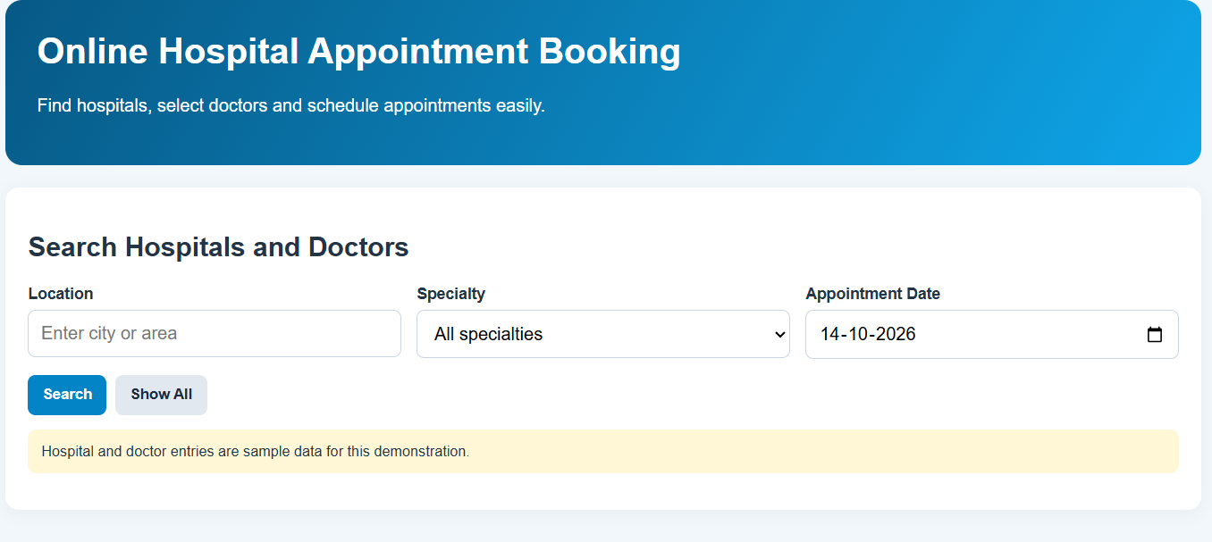
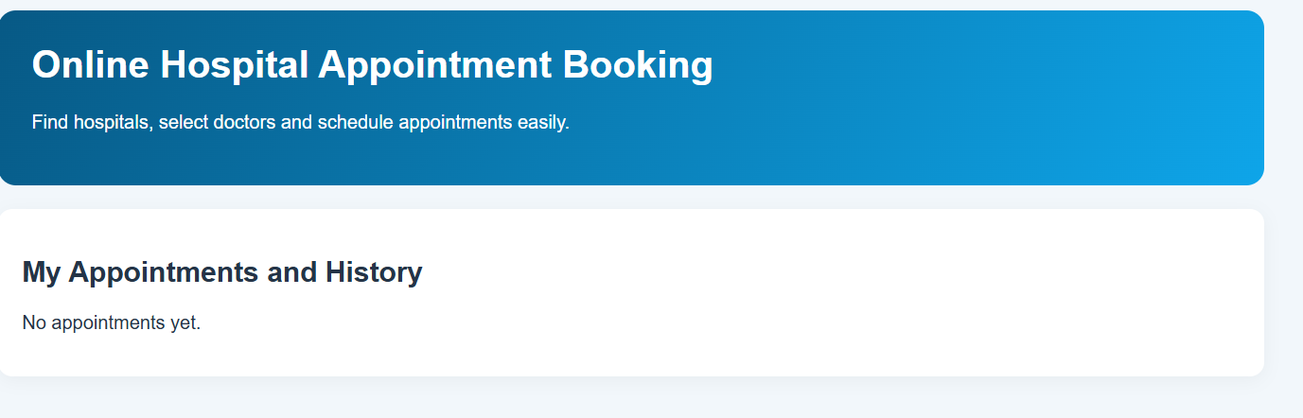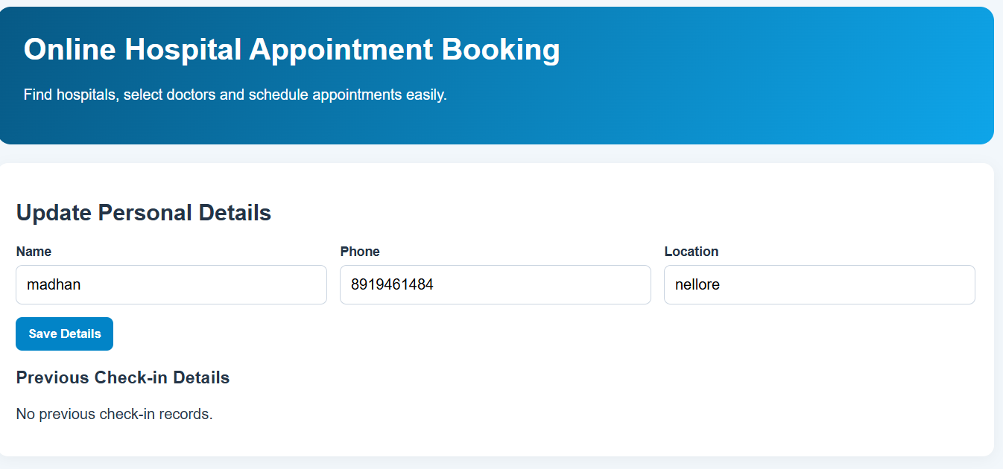
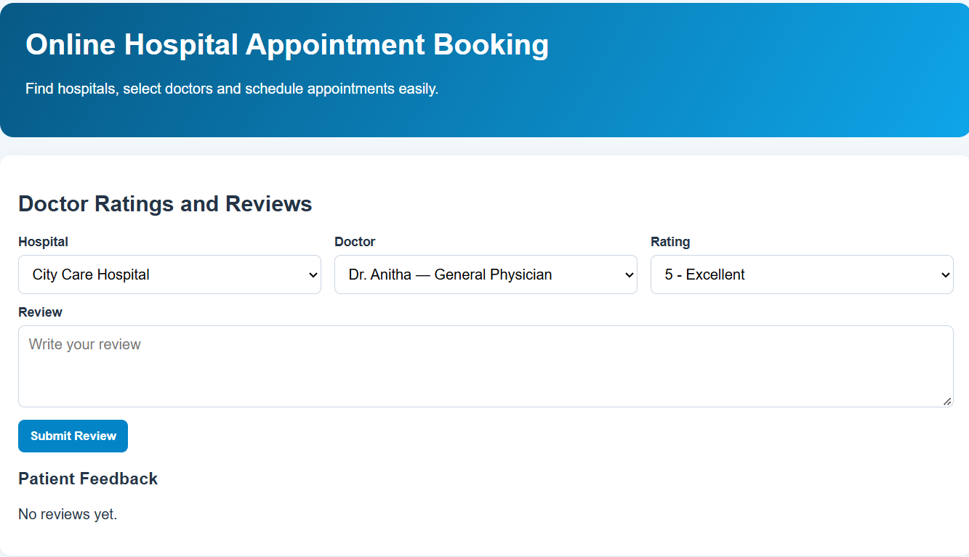
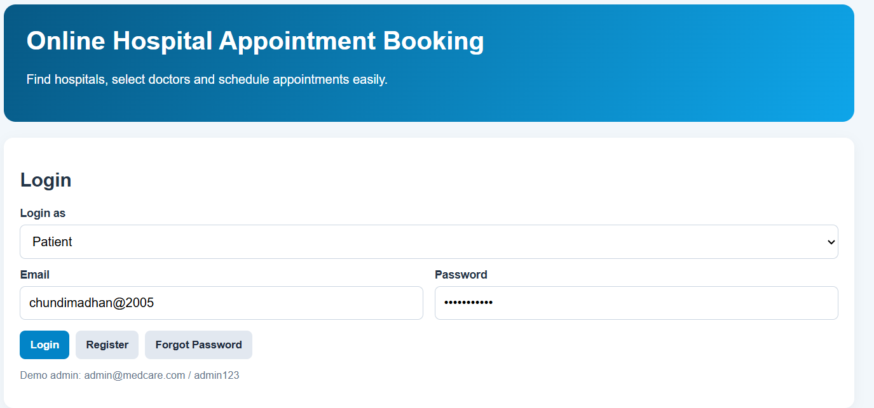
Result : Thus, the online hospital appointment booking system was developed successfully to simplify patient appointment scheduling, improve hospital appointment management, and reduce waiting time.

